**INTERNET AND WEB TECHNOLOGIES REPORT**

Research Paper Management System

Submitted in partial fulfillment of the requirements for the award of degree

## BACHELOR OF ENGINEERING

**in**

## COMPUTER SCIENCE AND ENGINEERING

**by**

**Abhinav TEJ(160120748022)**

**Gowtham Sai(160120748028)**

**Kowshik Ranga(160120748031)**

**Manav M (160120748035)**

**Sai Nihar (160120748042)  
 Yeshwanth Kondabolu(160120748060)**



**Department of Computer Science and Engineering,**

## Chaitanya Bharathi Institute of Technology (Autonomous),



## CERTIFICATE

This is to certify that the INTERNET AND WEB TECHNOLOGIES project titled “**Research Paper Management System**” is the bonafide work carried out by Abhinav Tej(160120748022),Gowtham sai(160120748028),Kowshik Ranga(160120748031),Manav M(160120748035) Sai Nihar(160120784042),YESHWANTH KONDABOLU(160120748060) a student of B.E.(CSE) of Chaitanya Bharathi Institute of Technology(A), Hyderabad, affiliated to Osmania University, Hyderabad, Telangana(India) during the academic year 2021-2022, submitted in partial fulfillment of the requirements for the award of the degree in Bachelor of Engineering (Computer Science and Engineering ).

**Mentor(s)**

**Shri Srikanth**

Assistant Professor Department of CSE

CBIT , Hyderabad

**ABSTRACT**

In the context of a research and development department of an enterprise, researchers regularly access, review, and use large amounts of literature, yet none of the exiting tools and solutions provide the wide range of functionalities required to properly manage these resources. Indeed, bibliography management systems manage the references and citations but fail to help researchers handle and locate resources. On the other hand, research paper recommendation systems and specialized search engines help researchers locate new resources, but again fail to help researchers manage the

resources. Finally, Enterprise Content Management systems offer the required functionalities to manage resources and knowledge, but are not designed for research literature. In this work we propose a new class of management systems: Research Paper Management Systems. Moreover, to illustrate our approach we highlight our system Papyres which combines various tools and functionalities, including Web2.0 technique, enabling researchers to maintain and manipulate bibliographies, as well as to manage and share resources and knowledge. Finally, we report on the implementation and

validation of Papyres.

# ACKNOWLEDGEMENTS

We would like to express our heartfelt gratitude to Srikanth sir our project guide for their valuable guidance and constant support along with her capable instructions and persistent encouragement.

# TABLE OF CONTENTS

|  |  |
| --- | --- |
| TOPIC | Page No. |
| Problem Description | 6 |
| Objective | 6 |
| Project Details | 6 |
| Steps used to solve Problem | 8 |
| Output | 10 |
| GOOGLE DRIVE LINK | 13 |
| TECHNOLOGY STACKS USED | 13 |
| REFERENCES | 13 |

## INTRODUCTION

### PROBLEM DESCRIPTION :

### Researchers regularly take notes on resources, and require to easily manage these comments and to track the status of the resource. Specifically, when coming across a resource, the researchers must easily recognize if they already read this resource, whether they did take notes and write comments on the resource, to review these comments, and to quickly recognize whether they considered the resource as valuable and interesting or not.Hence with our project they can review the papers by putting in their login credentials and access the datas

researchers regularly take notes on

resources, and require to easily manage these comments and to

track the status of the resource. Specifically, when coming

across a resource, the researchers must easily recognize if they

already read this resource, whether they did take notes and

write comments on the resource, to review these comments,

and to quickly recognize whether they considered the resource

as valuable and interesting or not.

researchers regularly take notes on

resources, and require to easily manage these comments and to

track the status of the resource. Specifically, when coming

across a resource, the researchers must easily recognize if they

already read this resource, whether they did take notes and

write comments on the resource, to review these comments,

and to quickly recognize whether they considered the resource

as valuable and interesting or not.

researchers regularly take notes on

resources, and require to easily manage these comments and to

track the status of the resource. Specifically, when coming

across a resource, the researchers must easily recognize if they

already read this resource, whether they did take notes and

write comments on the resource, to review these comments,

and to quickly recognize whether they considered the resource

as valuable and interesting or not.

researchers regularly take notes on

resources, and require to easily manage these comments and to

track the status of the resource. Specifically, when coming

across a resource, the researchers must easily recognize if they

already read this resource, whether they did take notes and

write comments on the resource, to review these comments,

and to quickly recognize whether they considered the resource

as valuable and interesesearchers regularly take notes on resources, and require to easily manage these comments and to track the status of the resource. Specifically, when coming across a resource, the researchers must easily recognize if they already read this resource, whether they did take notes and write comments on the resource, to review these comments, and to quickly recognize whether they considered the resource as valuable and interesting or not.

researchers regularly take notes on

resources, and require to easily manage these comments and to

track the status of the resource. Specifically, when coming

across a resource, the researchers must easily recognize if they

already read this resource, whether they did take notes and

write comments on the resource, to review these comments,

and to quickly recognize whether they considered the resource

as valuable and interesting or not.

### OBJECTIVE :

* To meet the requirement of regular check on research notes
* To keep track of resource
* To make it user friendly

### PROJECT DETAILS:

### In this Research Paper Management System we are using Django, HTML, CSS5, JavaScript to develop it. Proper paper management and privacy is an integral part of a management’s operations. That’s why we focussed a lot on improving user experience by removing hassles and enhancing the facilities they provide. Storing a research paper in our website usually requires a person write down the paper physically, fill out a form, get authentication and submit the necessary papers. All of these tasks take up a lot of time and dampen the overall user experience. Moreover, many people have to take time out of their important schedules to do such these activities.

### For creating a new account we need the following details

### Login ID

### Password

### If a user has a account then by using his/her login-id they can access the following:

### List of all the papers already prepared.

Option to add new paper

### Steps Used To Solve The Problem

1. Need to install django on system
2. Created a new project
3. In new project created an app
4. I new app wrote an urls.py path and linked to project urls.py
5. In app created a floder that consists of html files
6. Used bootstrap to make responsive web pages(used bootstrap 4)
7. In home page create a gallery slider using bootsrap4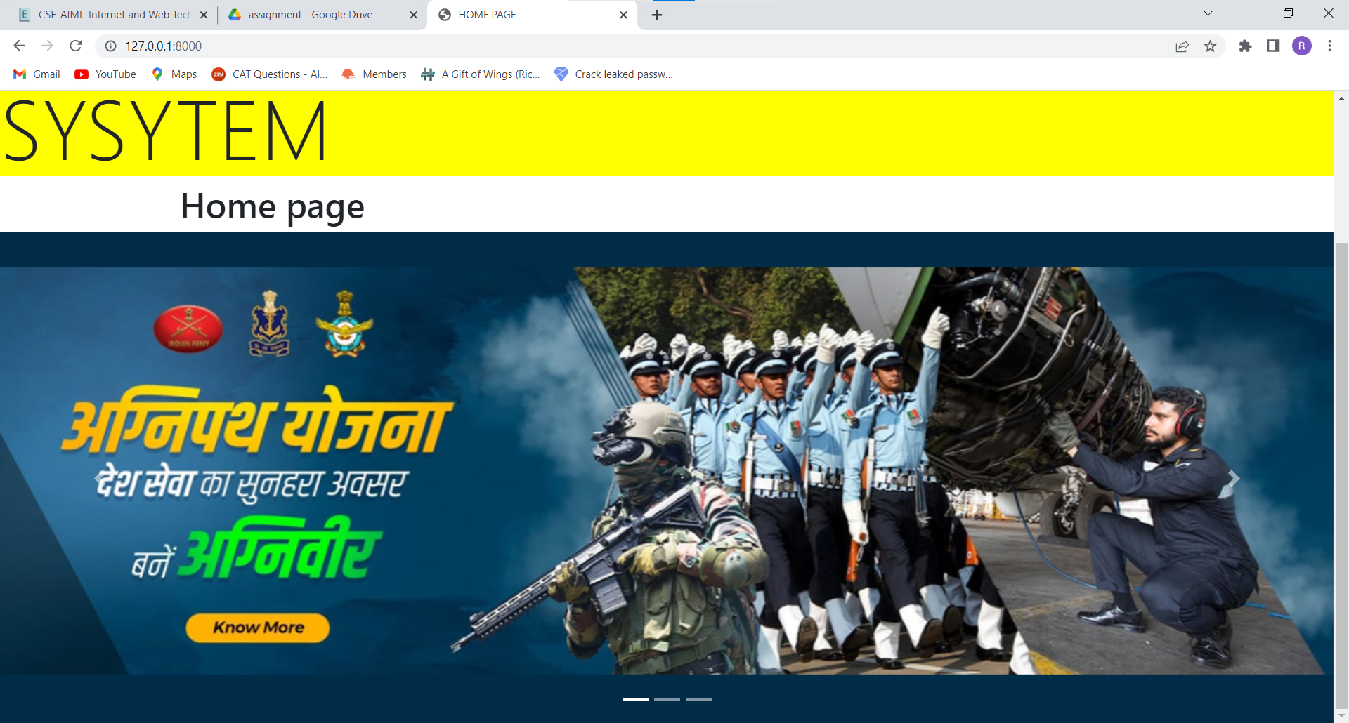
8. In this app used forms,models, authenticate, login, logout, update_session_auth_hash, SignUpForm, EditProfileForm, UserCreationForm, UserChangeForm
9. In this app used crud operations
10. For login and register created separate two html files and add the user in the database and for login authenticated the user with username and password.

## OUTPUT SCREENSHOTS

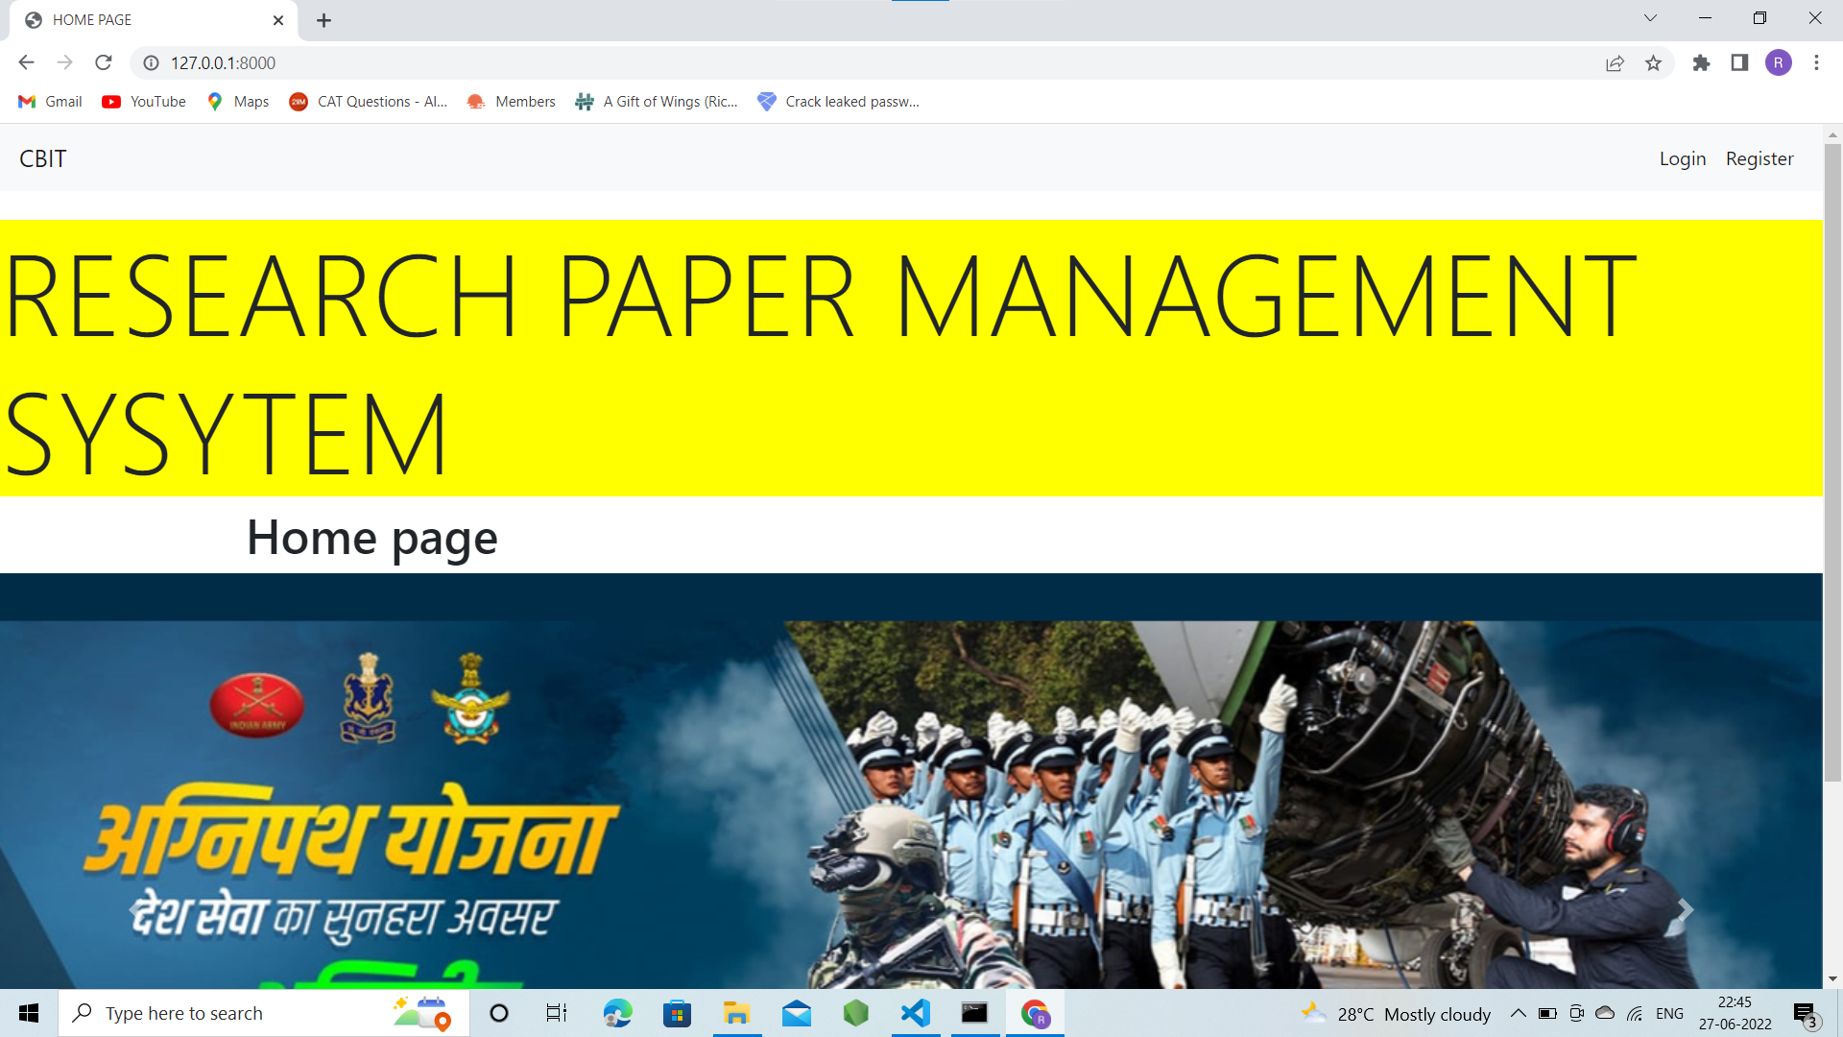

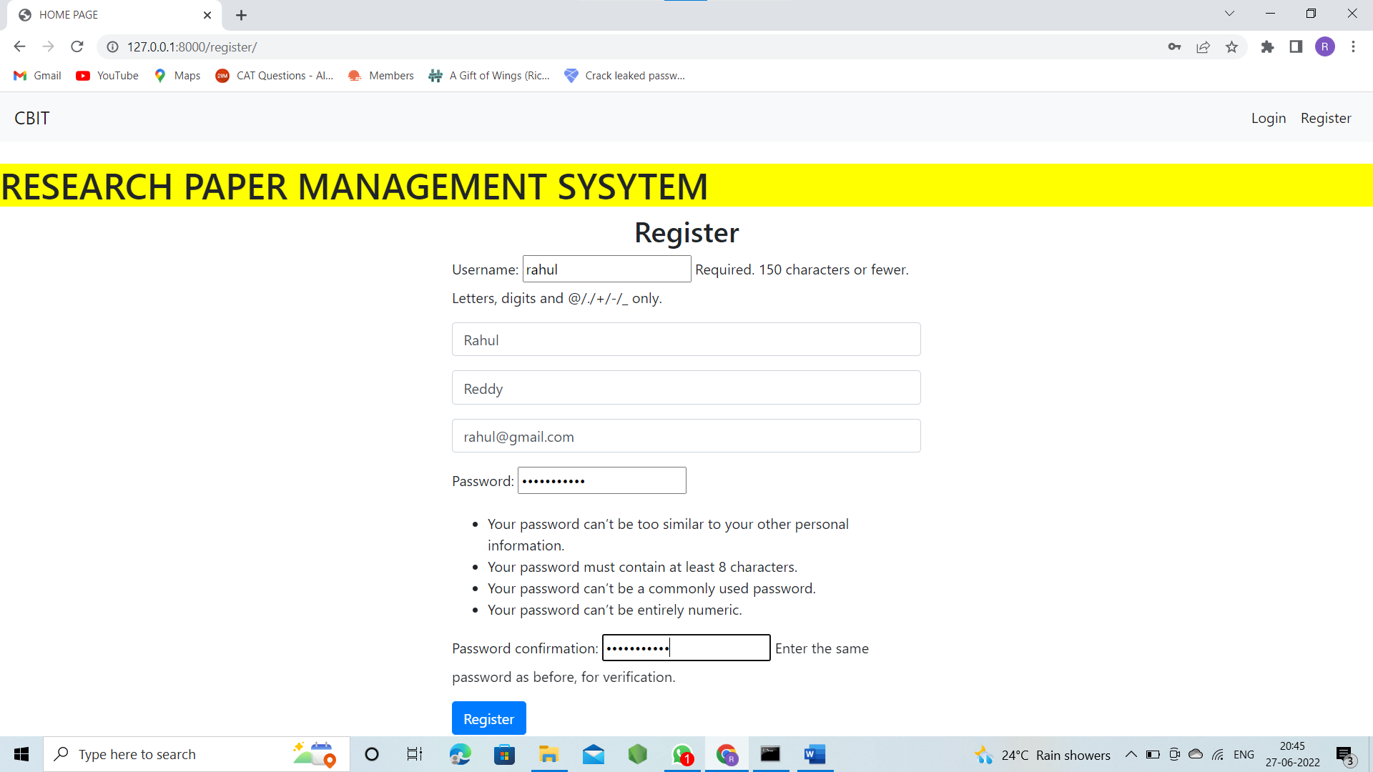

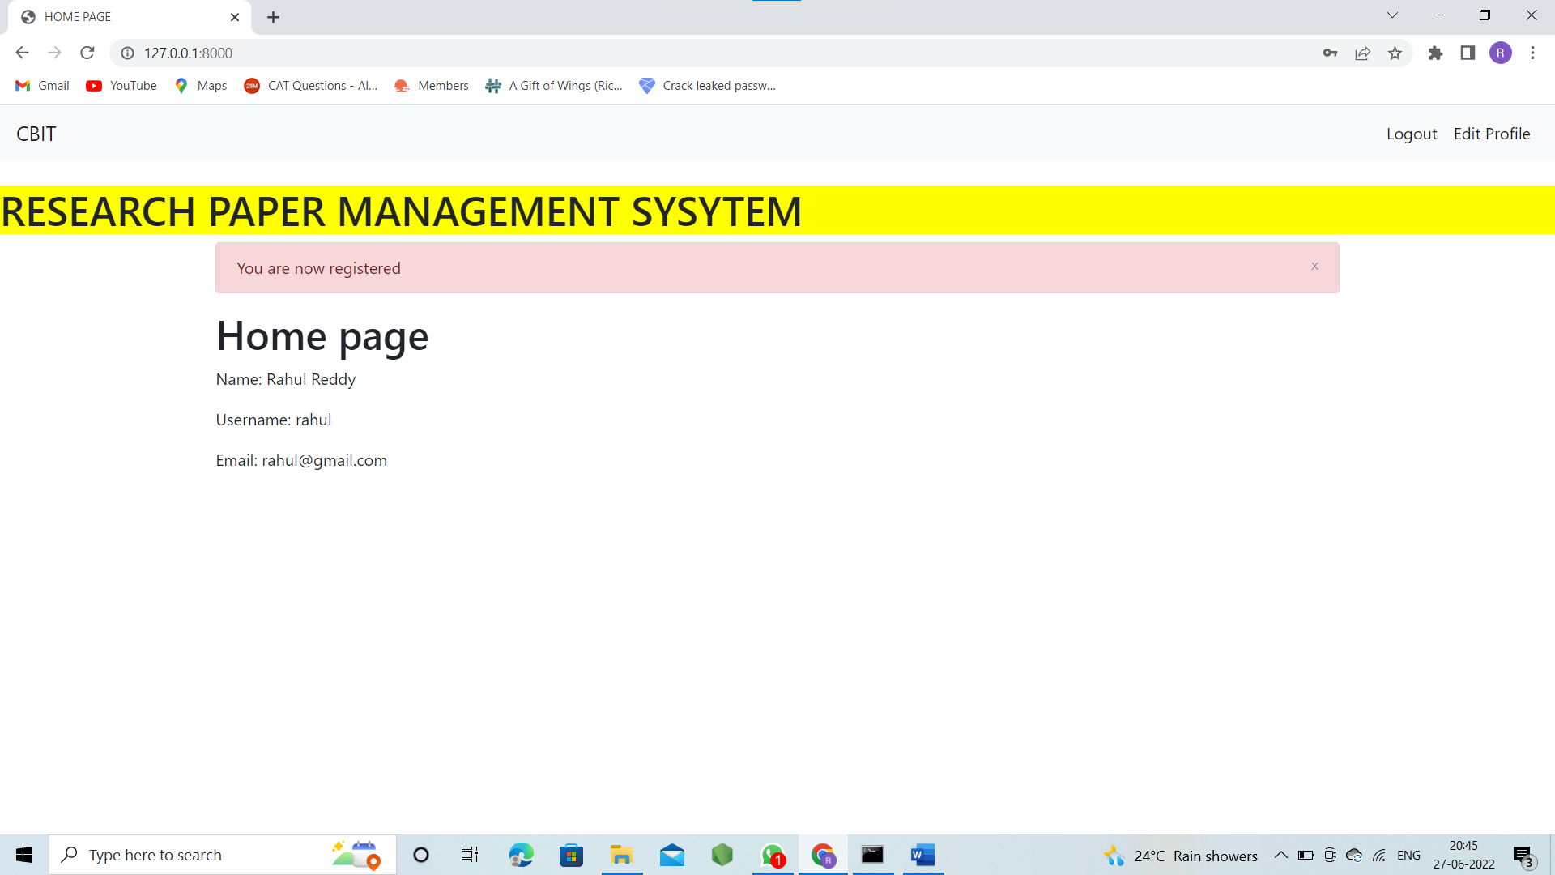

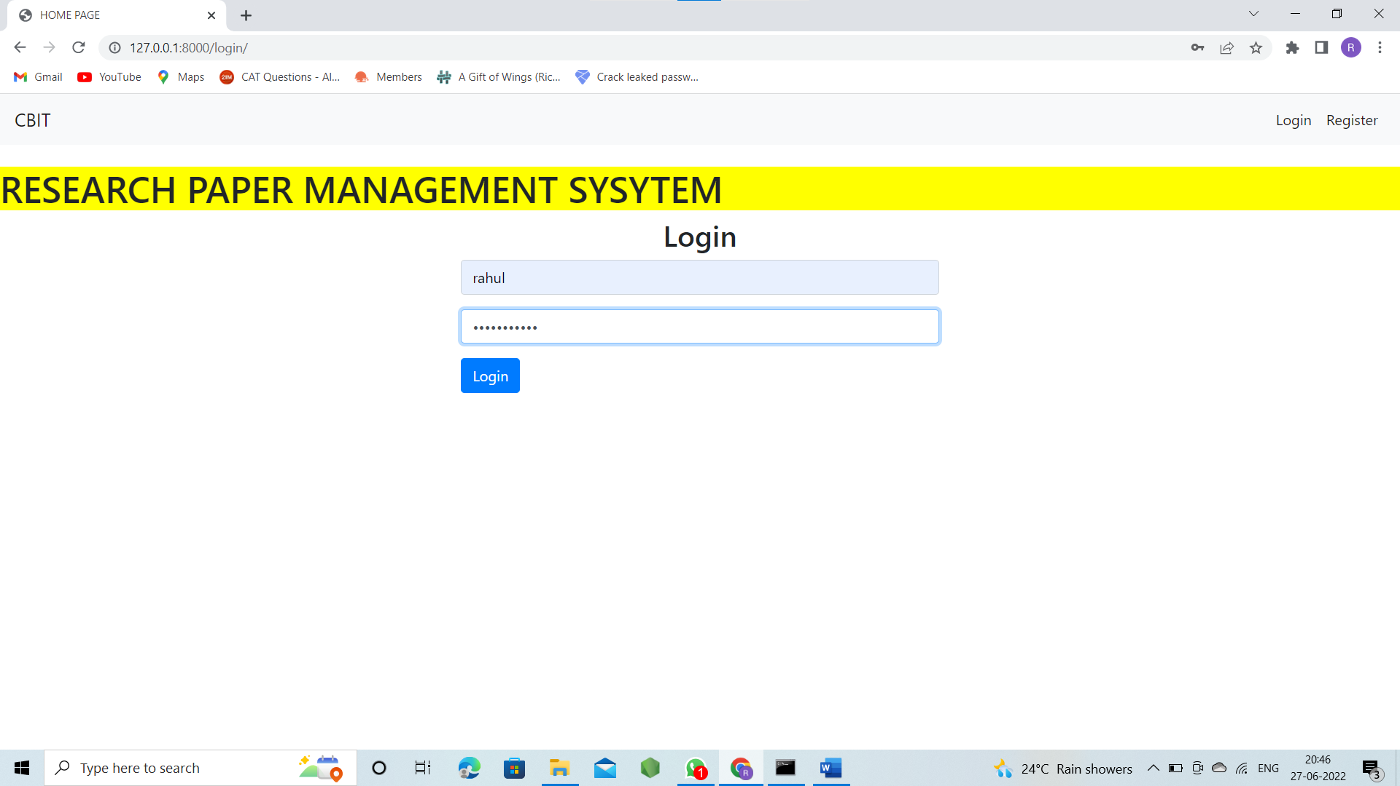

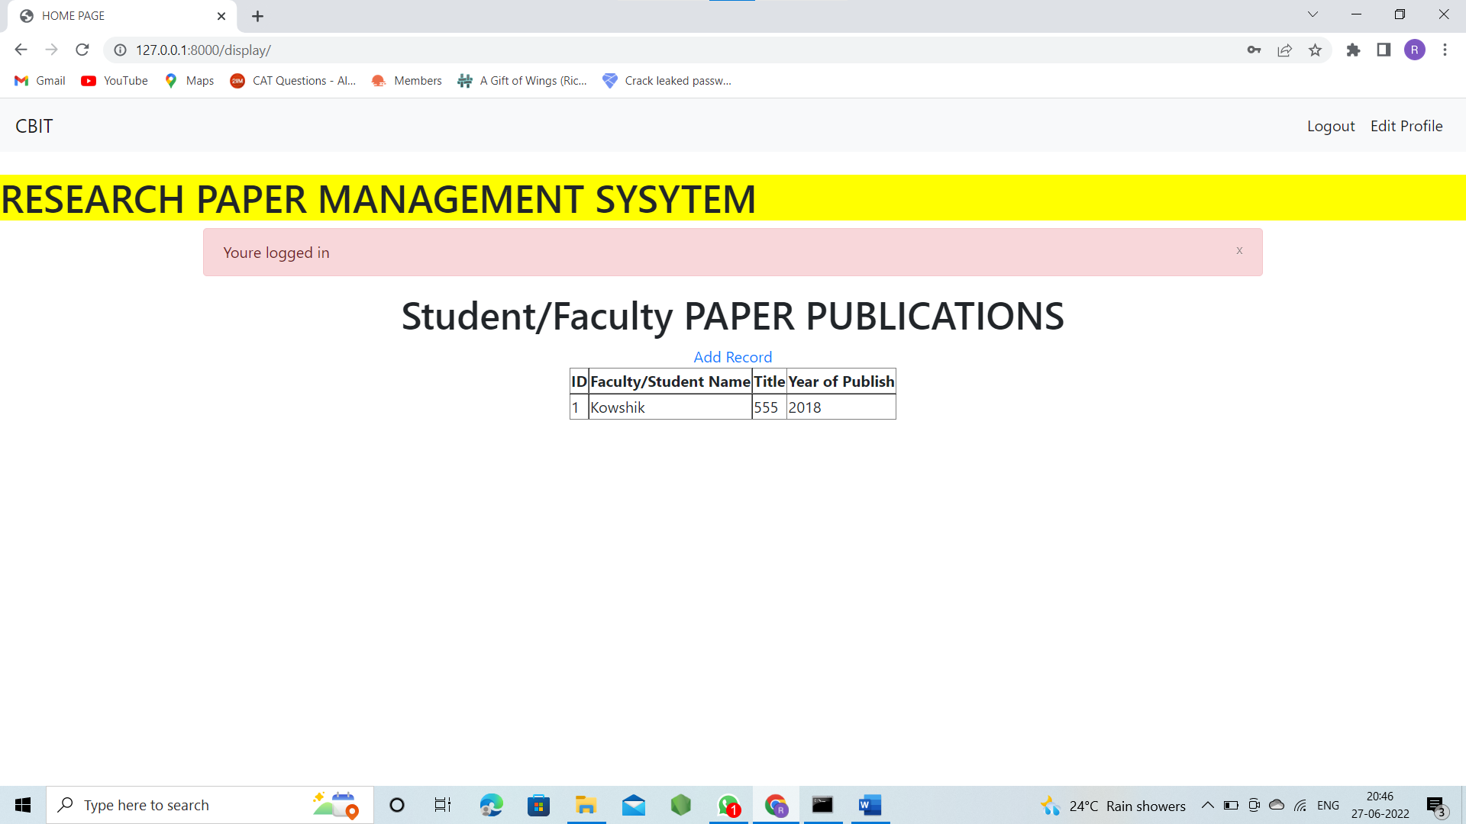

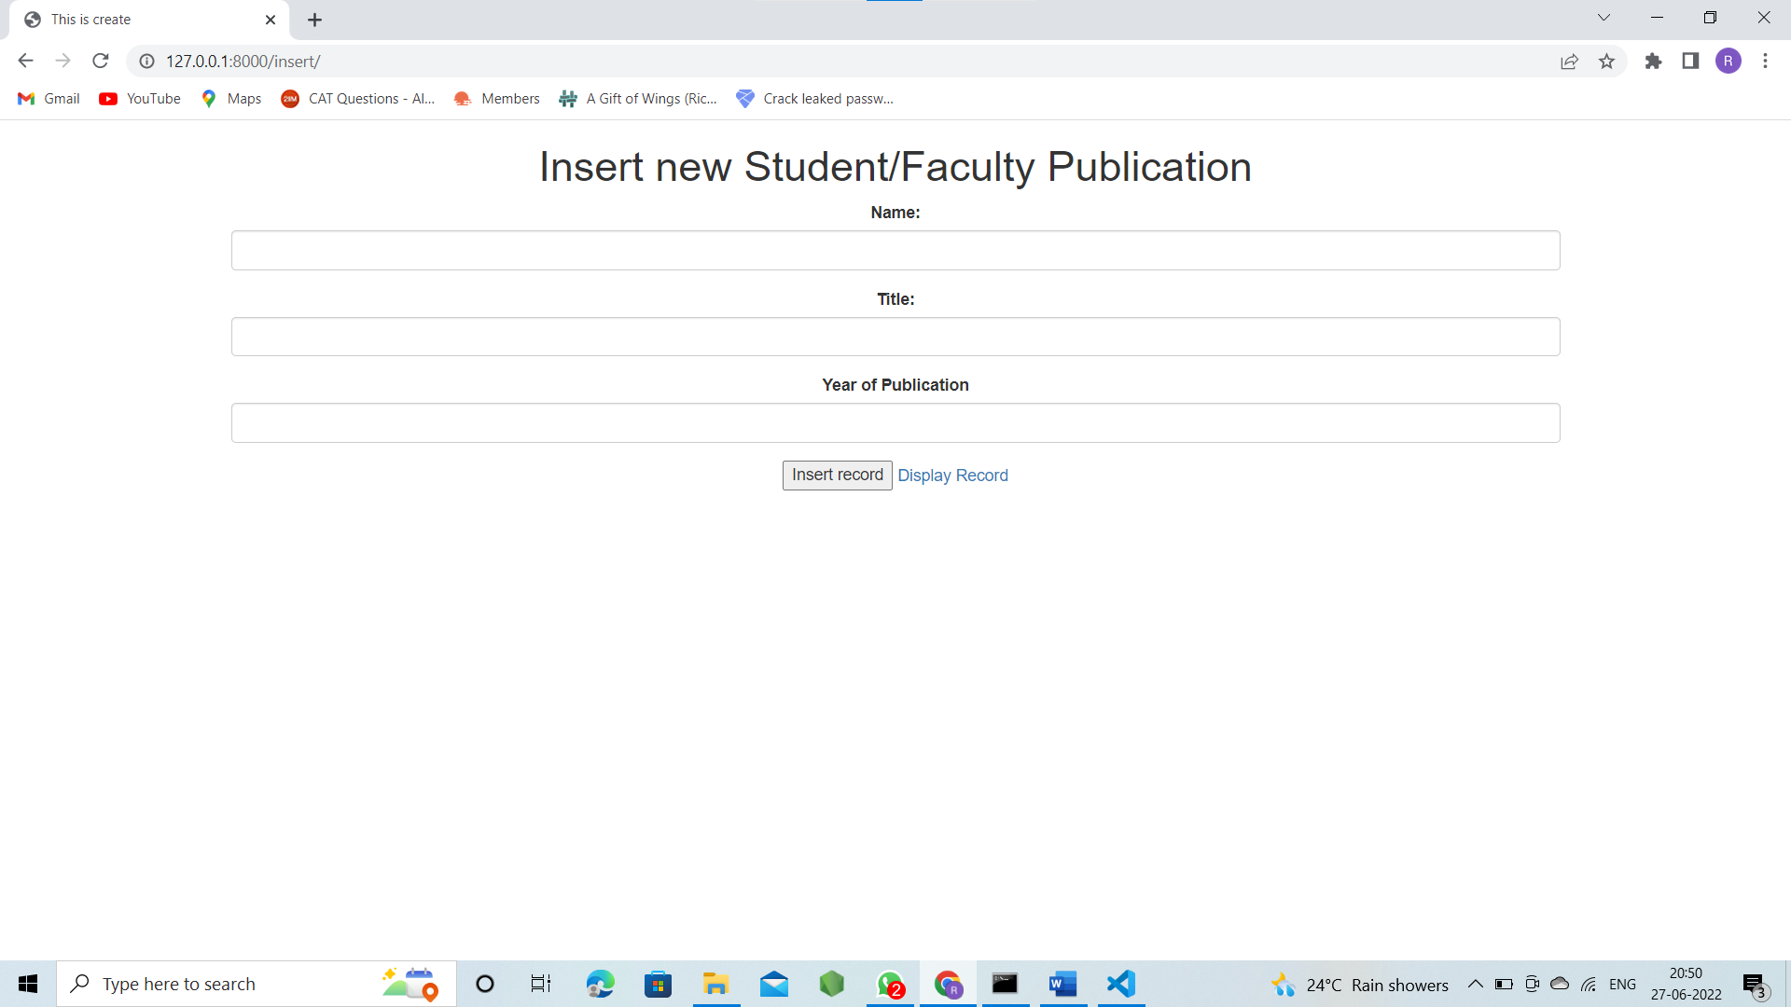

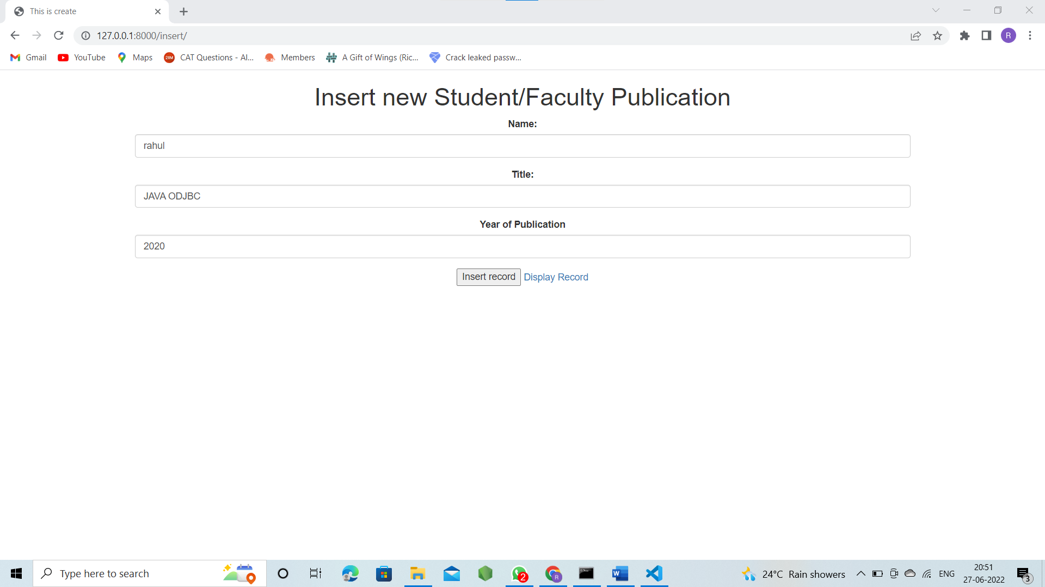

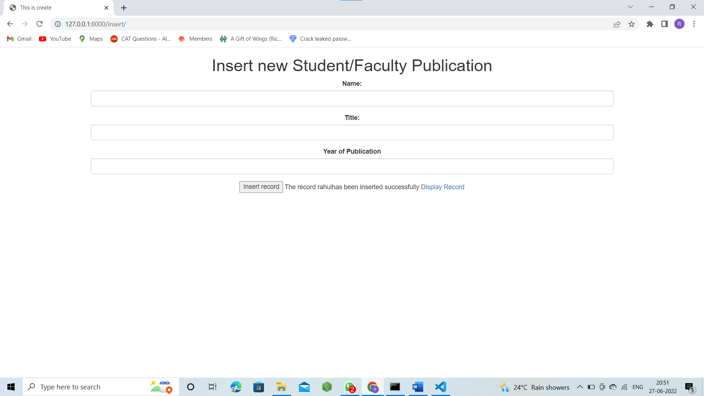

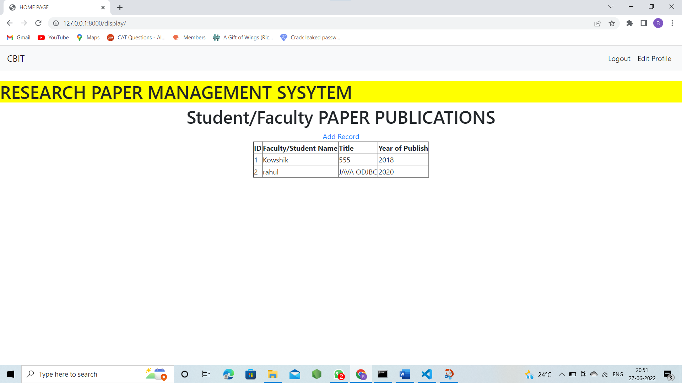

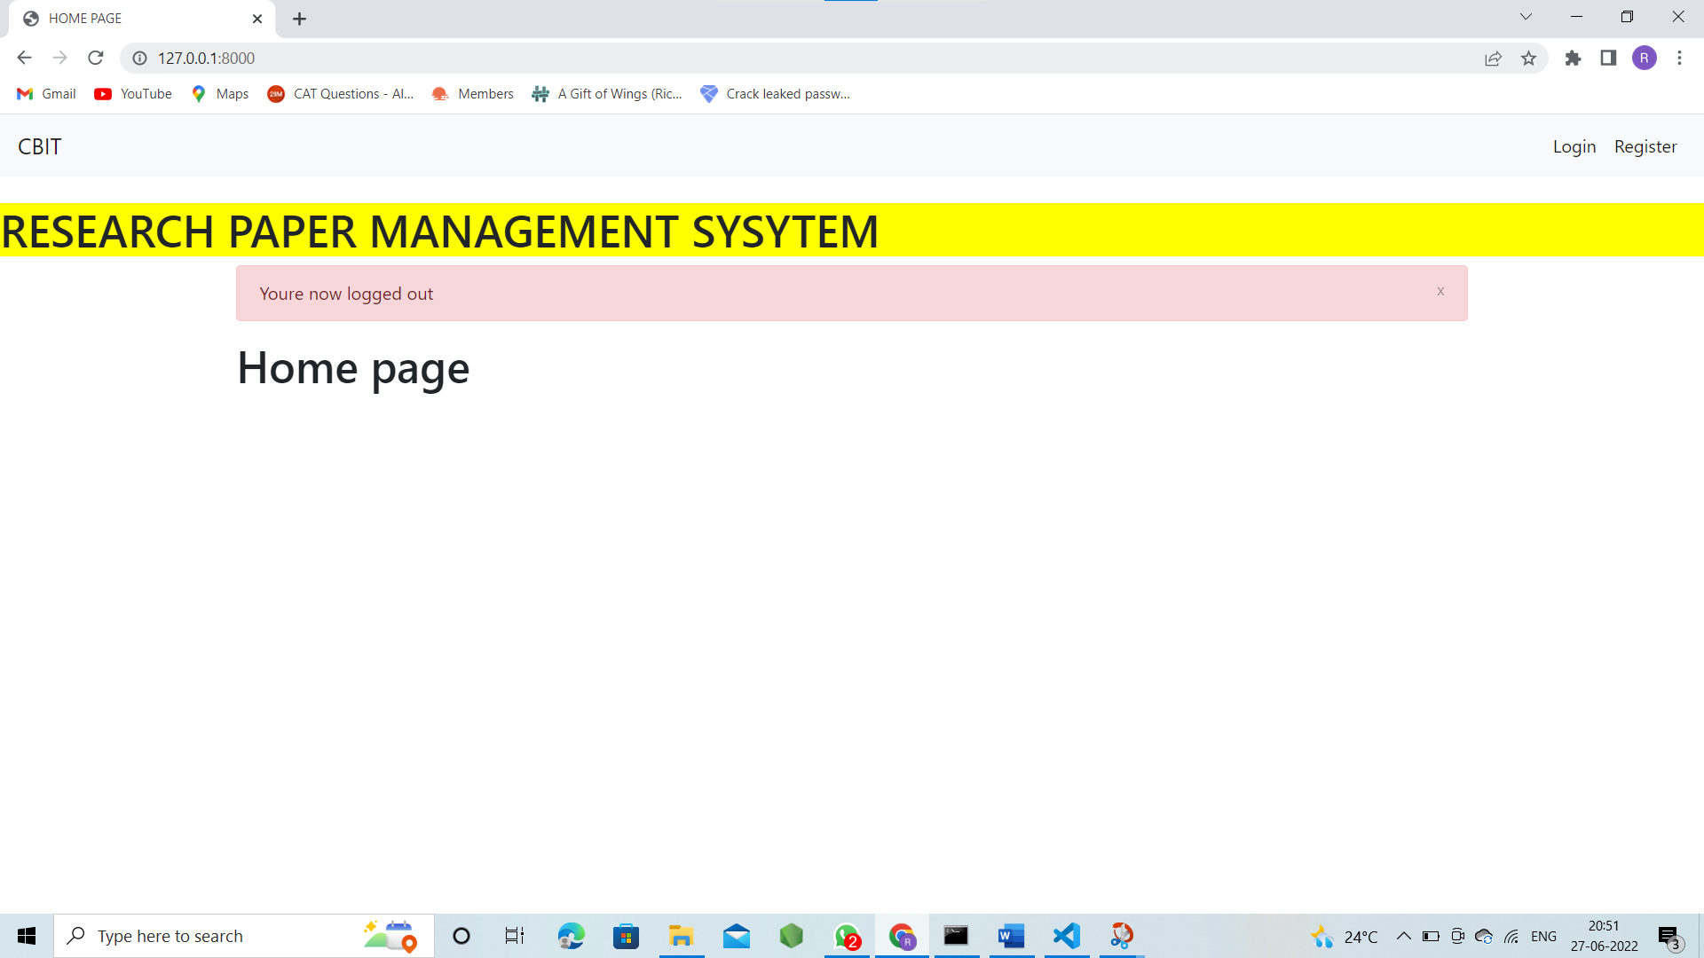

**GOOGLE DRIVE LINK:**

<https://drive.google.com/drive/u/0/folders/14NljL7j51b7u0uj7nh9q12MHt2BOrpHS>

**TECHNOLOGY STACKS USED:**

WEB APPLICATION FRAMEWORK : DJANGO

HTML

CSS

BOOTSTRAP

**REFERENCES:**

<https://docs.djangoproject.com/en/4.0/topics/install/>

<https://getbootstrap.com/>

<https://docs.djangoproject.com/en/4.0/topics/install/>